Unit of a long term plan: Unit 9 Reading for pleasure. |  | Lesson 58
Teacher name: Meirkhan A.S. |  | “Darazhol” boarding school lyceum

Date: 26.01.24
Grade: 5 “B” |  | Number present: | absent:
Lesson title | A Famous story
Learning objectives | 5.5.1.1 plan, write, edit and proofread work at text level with support on a limited range of general and curricular topics  5.4.3.1 understand the detail of an argument on a limited range of familiar general and curricular topics;  5.3.3.1 Give an opinion at sentence level on a limited range of general and curricular topics;  5.6.1.1 use Past Simple to tell a story.  5.1.7.1 develop and sustain a consistent argument when speaking or writing;
Lesson objectives | Learners will be able to:  • Learn and practise verbs to talk about the past.  • Understand stories written in the past tense.
Value links | Kindness – If you value kindness, you’ll likely always be respectful of people around you, be gentle with criticism, and always willing to welcome people with open arms.
Plan

Stages / Time | Teachers’ actions | Students’ actions | Assessment criteria | Resources
Beginning of the lesson  5 min  10 min | Organization moment  1.Greeting.  Ask about their mood  Warm-up  Lead – In  2. Check ss homework (Type of writing)  - What is the Past simple?  - When we use the Past simple?  - Write the form of Past simple  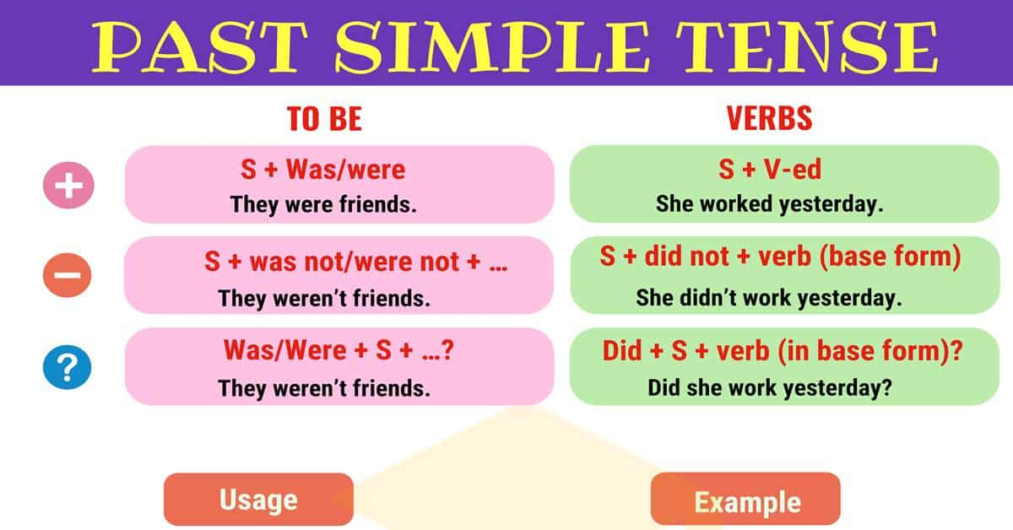  - For weak students  - For strong students | The aim: To develop Ss speaking skills and create friendly atmosphere  Efficiency: By telling their wishes they show their appreciations .  Ss answer :  1) A verb form used to say an action or series of actions that were completed in the past.  2) When we talk about actions started and finished in the past at a specific time in the past.  3) I/He/She/It was + V2/ed  You/We/They were+V2/ed  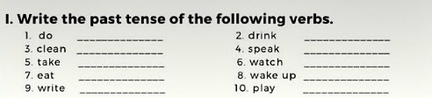  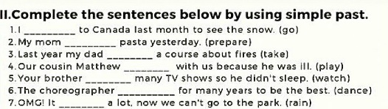 | At the organization moment T tries to award active Ss.  «The cookie » method is used to evaluate Ss with points.  Formative Assessment      Assessment criteria  - Learn and practise verbs to talk about the past.  3 points  Individual work | Smiles  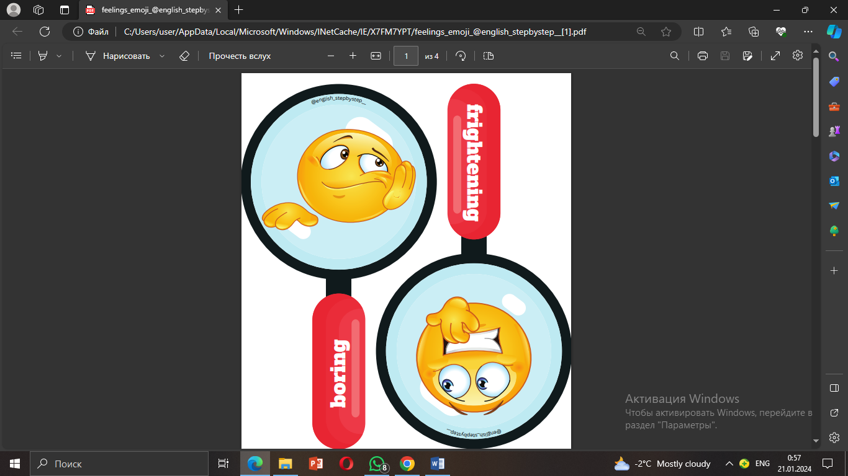  https://wordwall.net/resource/66961034  Whiteboard
Middle of the lesson  Presentation part.  25 min |   3. Watch the video about Kozy Korpesh And Bayan Sulu  Books closed. Ask the class what they know about the Kozy-Korpesh and Bayan-Sulu story. Ask students why the story is so famous.  Ex: 1 P: 106  • Do the exercise with the whole class. Make sure students understand warrior (a person who fights in battle).  Differentiation:  «Verbal support» method is used to help Students use new words in the text.  Ex: 2 P:106  • Explain the task. Make sure students understand these words before they start reading: steppe, rescue, revenge, stab.  • Give students plenty of time to read the story and find the answers.  • Go through the answers. In a stronger class, ask students to read the part of the story that answers the question, e.g. for question 1 ‘Karabay had a daughter called Bayan.’ If any sentences are false, ask students to make a true sentence.  • In a weaker class, read the story to the class and stop at the sentence which helps answer the question.  Ex: 3 P:106  • Tell students to look quickly at the story again and find the five words.  • In a weaker class, stand up in front of the class and point to your hair, waist, neck. Ask the class to say each time what you are pointing at. Mime combing, tidying, wearing (round the neck and waist), and cutting (hair with a knife).  • Go through the answers.  Extra task “Find the words”  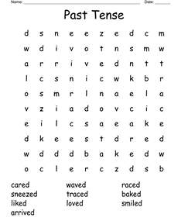 | The ancient legend tells that two childhood friends, Syrybay and Karabay, decided to marry their children, who had been engaged even before they were born. Unfortunately, Syrybai died while hunting before his son was born. Growing up, Kozy and Bayan met and fell in love with each other, which made their families very happy. Having grown up, Kozy and Bayan-Sulu do end up falling in love with each other  Students identify who are characters in the story. Match the names with the roles.  ANSWERS:  1 daughter  2 lover  3 father  4 warrior  Students read the text and write true or false.  ANSWERS:  1 true  2 false  3 false  4 true  5 true  6 false  7 false  8 true  Students find these words in the text. Match the words with definitions.  ANSWERS:  1 c  2 e  3 a  4 d  5 b | Descriptor:  - identify who are characters in the story. Match the names with the roles.  Assessment criteria:  - Understand stories written in the past tense..  Ss make a poster with the team  Descriptor:  - find these words in the text. Match the words with definitions.  2 points  Team work    3 points  Make CCQ questions  Yes / No  2 points  Team work  Team work | Video  https://youtu.be/7ysYf2QCJv4?si=xGCtLxbVJr1VD4Ld  Books  “Lays” method  
End of the lesson  5 min | Home task:  Ex: 2 P: 60 WB | 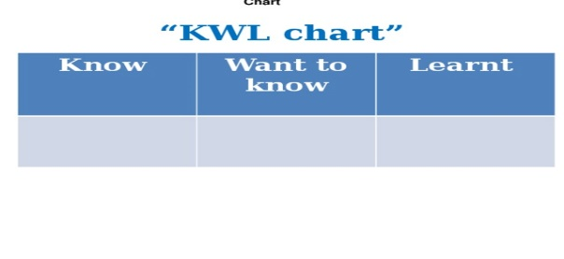 | Students use their stickers to show their knowledge according to the lesson. | Poster  KWL chart  

